**Task 1.4 - > Date Command Explorer in Linux**

**Documentation :->**

1. **Date Command: -** It gives the output of the todays date in the terminal or prompt in which u are typing the command.

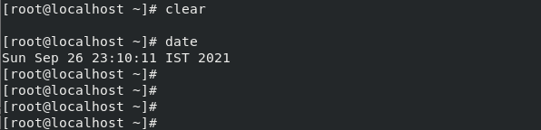

**Date Command comes with many options we can customize the output according to the need.**

* Abbr day using date command

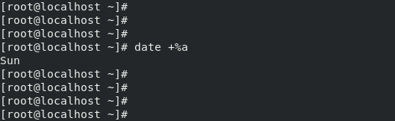

* Full name for the day

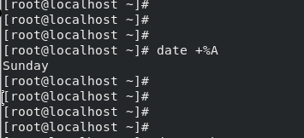

* Abbr Month using date command

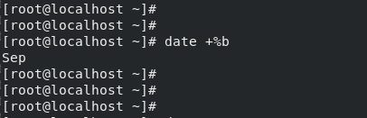

* Full name for the Month

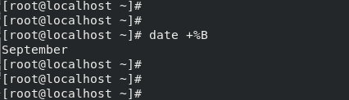

* Full form of the date without any abbr

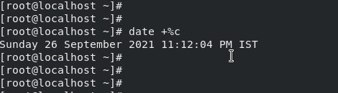

* To find the century of the date

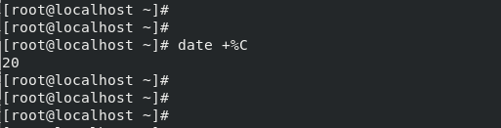

* To find the current date

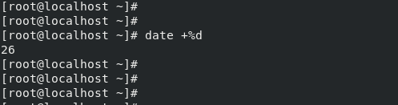

* To show the mm/dd/yy format

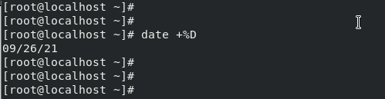

* To print only the time in hh/mm/ss format

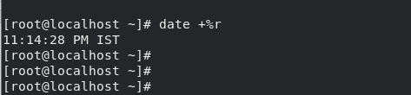

* To print only the time in 24 hour format

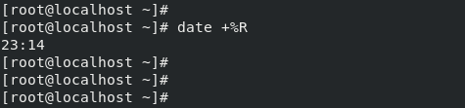

* Print the date by providing the seconds from @1.1.1970

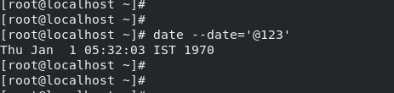

* We can print of different time zone

